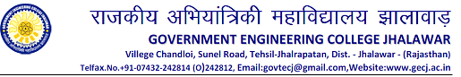
Computer Science and Engineering Department
Date: 09 / 04 /2014
Notice
All the B Tech VIII Semester students are hereby informed that the second Phase demo of Major project will be held on 24-25 April 2014. All the group members’ presence is compulsory and progress report is also to be submitted at the time of demo.

Head CS

